May 1st, 2019

First Last
Address
City, State Zip

Dear Neighbor,

Nurses like you make a difference every day, touching the lives and hearts of patients who are sick, scared, or in pain. As we celebrate National Nurses Week, I want to thank you for your dedication to your profession, and for the care and compassion you provide to patients and their families.

I also wanted to take this opportunity to update you on my efforts to improve hospital safety for both patients and nurses.

I recently supported House Bill 2604, which sets a safe maximum limit on the number of patients assigned to a nurse at one time. Right now, many nurses are stretched too thin in caring for very sick patients, making it difficult for you to provide medical attention, comfort, and emotional support to people who need it most. This legislation aims to improve the work environment for nurses, while helping ensure all patients are properly cared for.

I sincerely respect the work you do, and I remain committed to ensuring that nurses are valued and protected in the workplace. If you have any thoughts on how I may be helpful in the future or have questions on any new laws, please contact my constituent service office at (773) 736-0218 or on Facebook at www.facebook.com/repdamico/.

Sincerely,
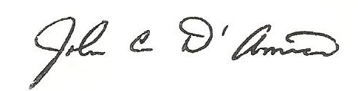

John D’Amico
State Representative, 15th District

